Worksheet for Class 2

# Researching the link between chocolate and acne

Imagine you are researching the link between eating chocolate and acne.

1. What are the variables? Are they numerical or categorical?
2. **Planning a correlational study**
3. What would make your study a correlational study?
4. How would you operationalise and measure your variables?
5. How could you collect your data?
6. **Planning an experimental Study**
7. What are the Independent and Dependent Variables?
8. Why might you want to run an experiment? What does it offer beyond a correlational study?

1. What could your experiment look like? What specifically would make it an experiment?

1. Would it involve randomisation and blinding? If so, how and why?

# Assessing the validity of studies

|  |  |  |  |  |
| --- | --- | --- | --- | --- |
| **Concept** | **What is it?** | **Correlational study** | **Experiment 1** | **Experiment 2** |
| Internal validity |  |  |  |  |
| Construct validity |  |  |  |  |
| External validity |  |  |  |  |
| Ecological validity |  |  |  |  |

1. **Correlational study**

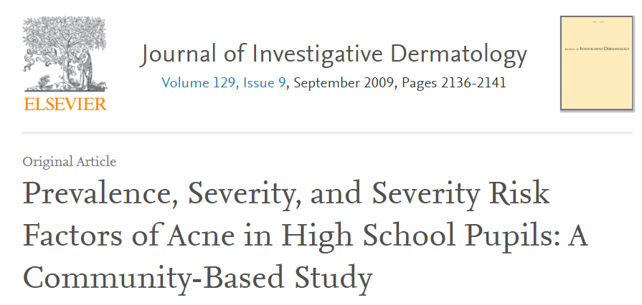

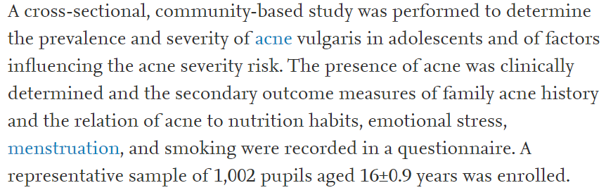

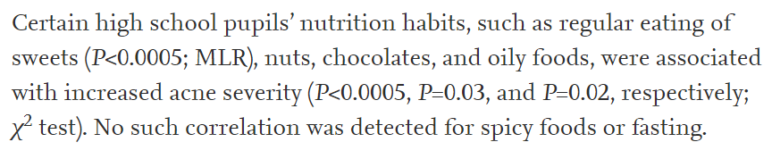

1. **Experiment 0**

This is the most cited study, but it reports very little detail and was funded by the Chocolate Manufacturers Association of America (Goh et al., 2011) – so let’s ignore it here and accept the need for further research.

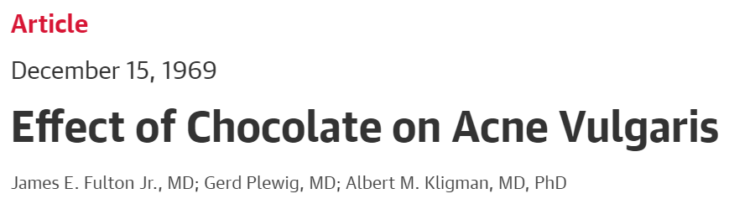

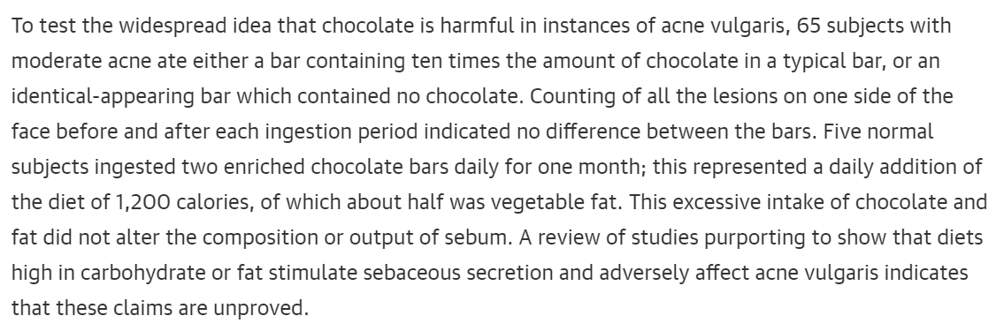

1. **Experiment 1**

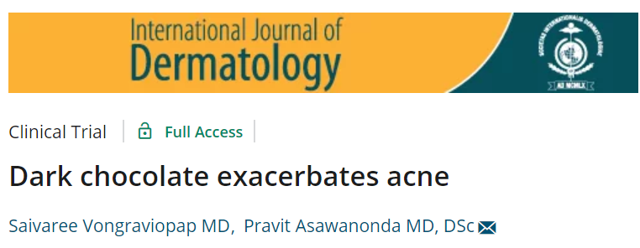

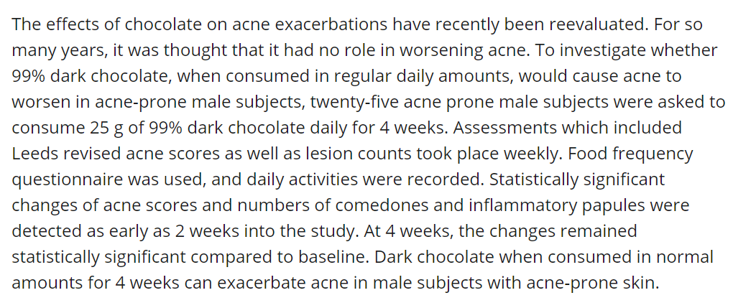

1. **Experiment 2** (JAAD 2016)



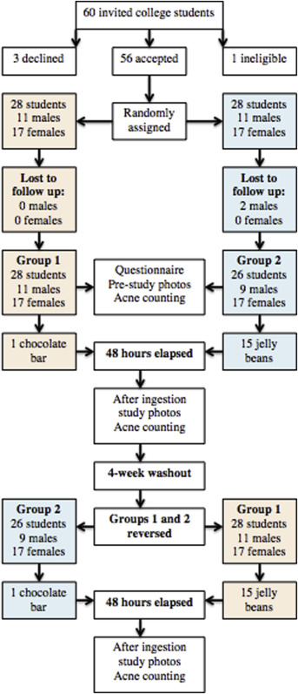

**Results:**

